SAMPLER OF RIBBONS (FOSA-DOG)
(code of ribbon, material, width)

# AD01 (grosgrain, 2,5 cm)

# AI01 (grosgrain, printing by golden colour, 2,5 cm)

# AS01 (grosgrain, 2,2 cm)

# BL01 (grosgrain, 2,5 cm)

# BU01 (grosgrain, 4 cm)
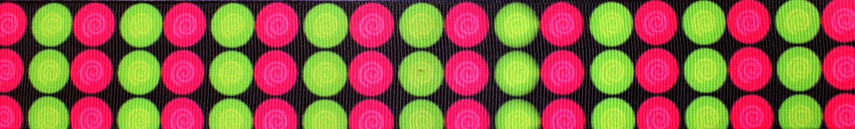

# BU02 (canvas, 2,2 cm)

#BU03 (canvas, 2,2 cm)

# BW01 (grosgrain, 2,5 cm)

# CA01 (seatbelt material, 4,7 cm)
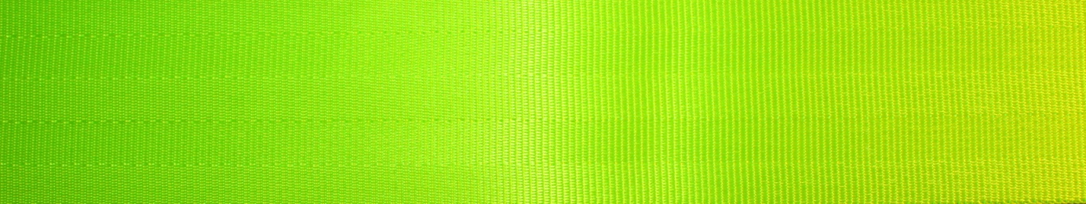

# CA02 (seatbelt material, 4,7 cm)
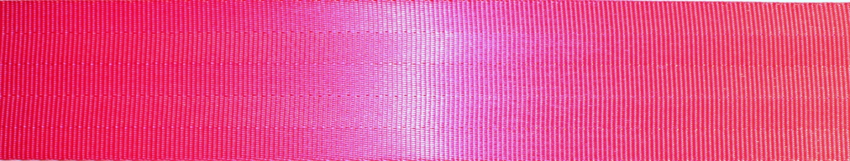

# CI01 (grosgrain, 3,8 cm)
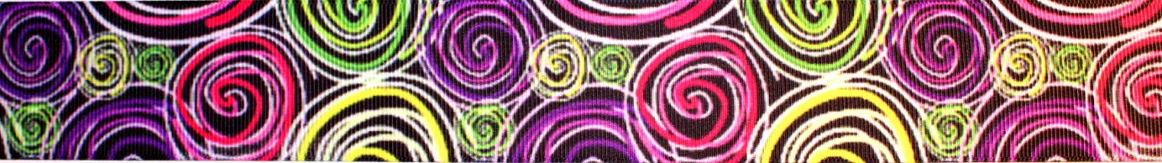

# CI02 (grosgrain, 3,8 cm)
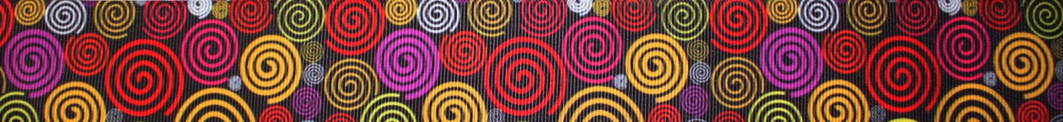

#CM01 (grosgrain, 2,5 cm)

#CM02 (grosgrain, 2,5 cm)
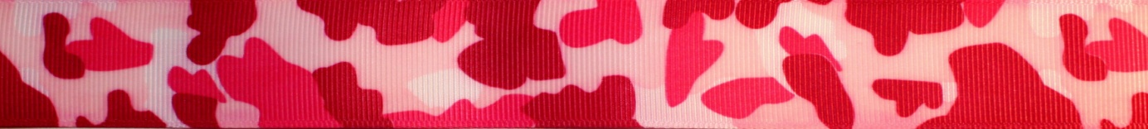

#CM03 (grosgrain, 2,5 cm)
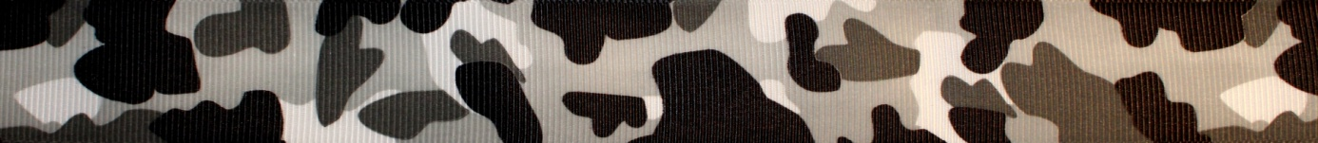

#CM04 (grosgrain, 2,5 cm)
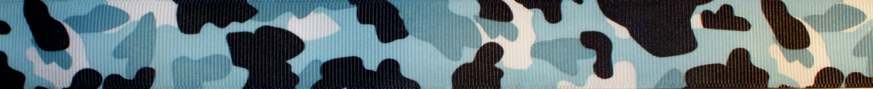

#CR01 (grosgrain, 2,5 cm)
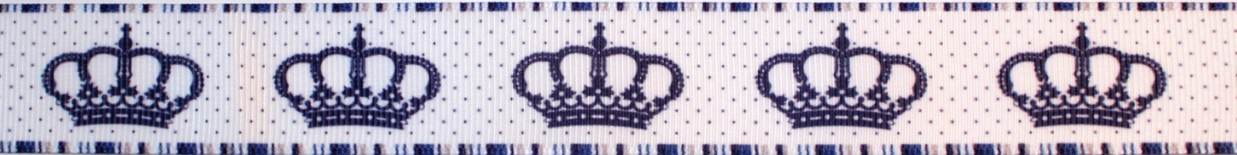

#CR02 (grosgrain, 2,5 cm)
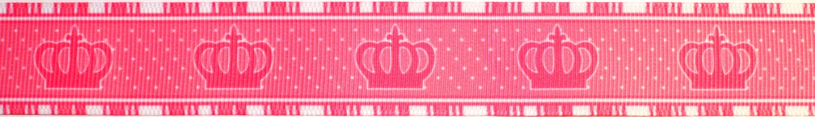

#CU01 (felt, 2,5 cm)
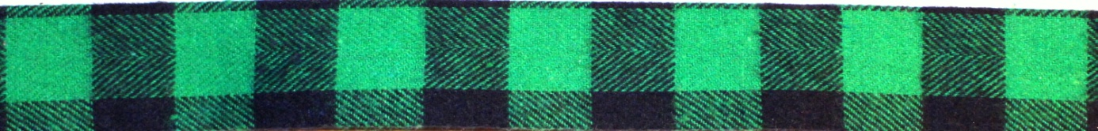
#CU02 (grosgrain, 2,5 cm)
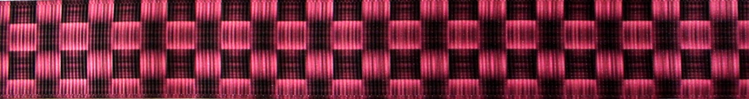

#CU03 (grosgrain, 2,5 cm)
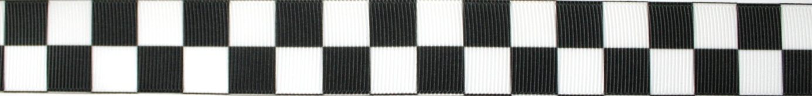

#DG01 (grosgrain, 2,2 cm)
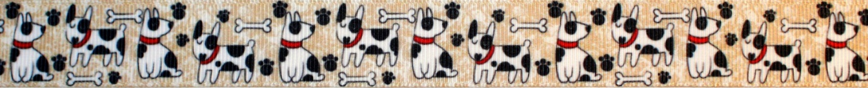

# EX01 (polyester, 2,5 cm)

#FR01 (elastic, 4 cm)
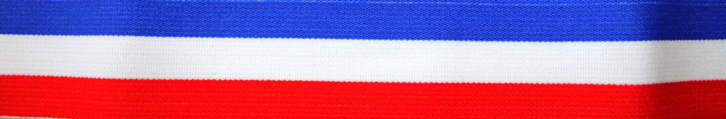

#FR02 (grosgrain, 2,5 cm, 4 cm, 5 cm)

#GC01 (grosgrain, 2,5 cm)
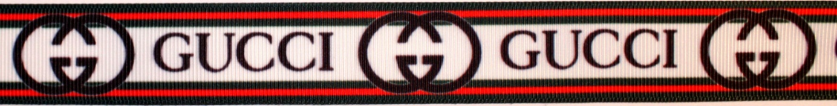

#GE01 (grosgrain, 2 cm, 4 cm)
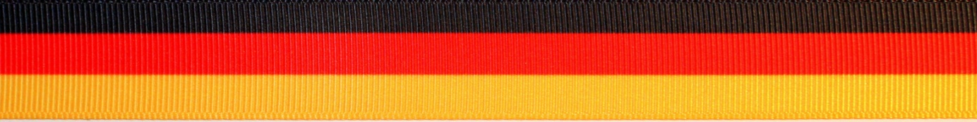

#HB01 (grosgrain, 2,2 cm)
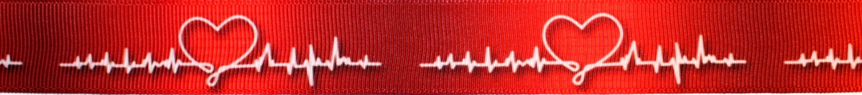

#HD01 (grosgrain, 2,5 cm)
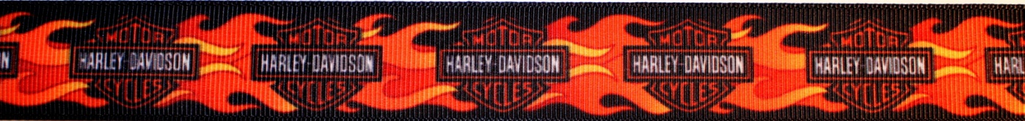

#HD02 (grosgrain, 2,5 cm)
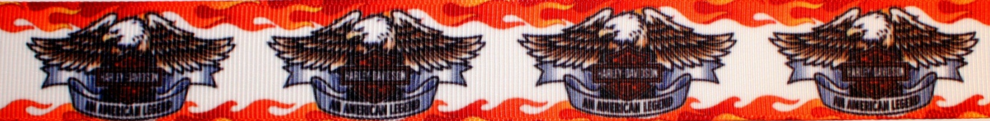

#HE01 (woven cotton, 2,2 cm)

#HE02 (woven cotton, 2cm)
#HE03 (woven cotton, 2 cm)

#HE04 (woven cotton, 2 cm)
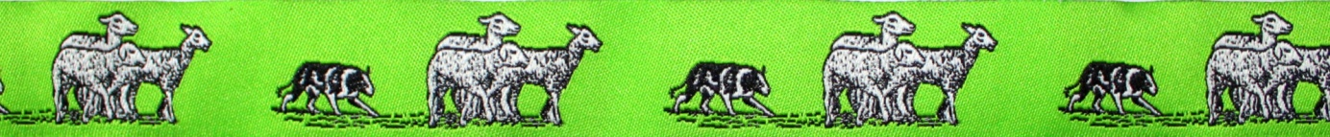

#HE05 (woven cotton, 2 cm)

#HE06 (woven cotton, 2 cm)

#HK01 (grosgrain, 2,5 cm)

#HR01 (grosgrain, 2,5 cm)

#IT01 (grosgrain, 2,2 cm)

#JN01 (denim, 2,5 cm, 4 cm)
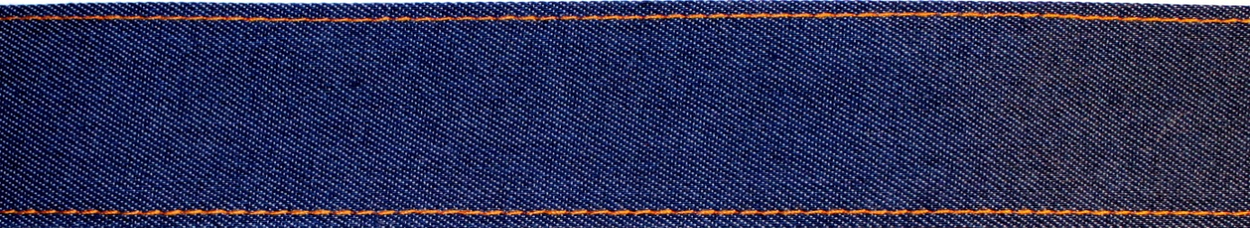

#JN02 (denim, 4 cm)
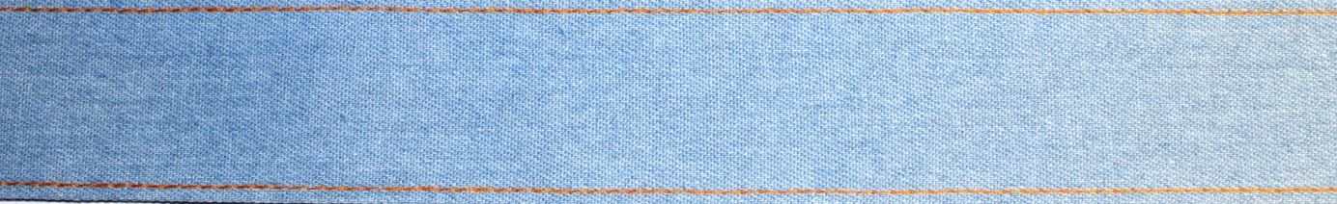

#LV01 (grosgrain, 2,5 cm)
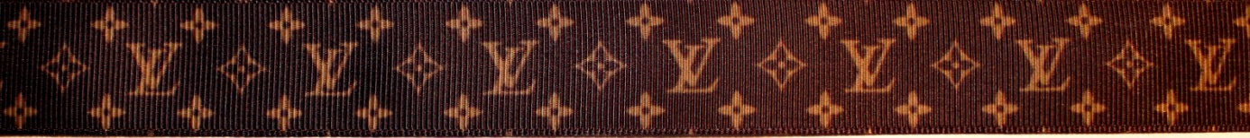

#LV02 (grosgrain, 2,5 cm)
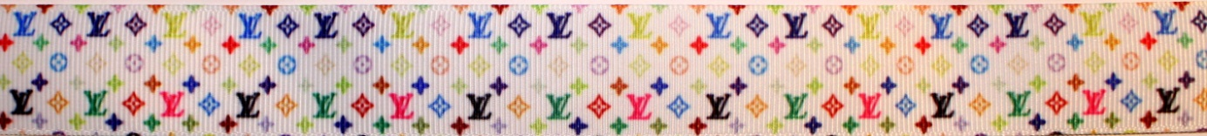

#LV03 (grosgrain, 2,5 cm)
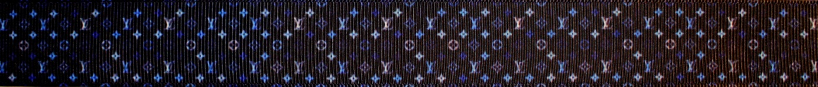

#LV04 (grosgrain, 2,5 cm)
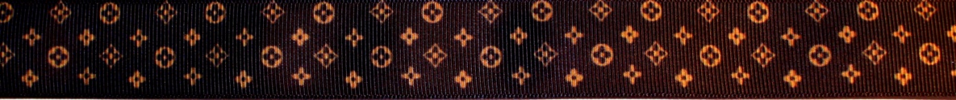

#MB01 (grosgrain, 2,5 cm)

#MM01 (grosgrain, 2,2 cm)
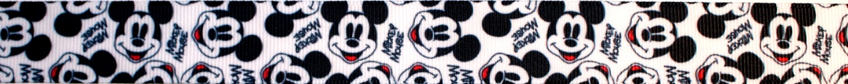

#MM02 (grosgrain, 2,2 cm)

#MM03 (grosgrain, 2,5 cm)
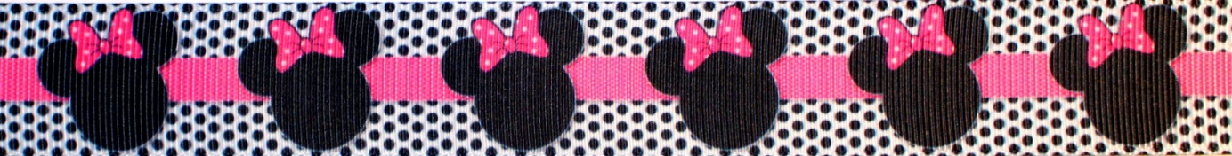

#MM04 (grosgrain, 2,5 cm)
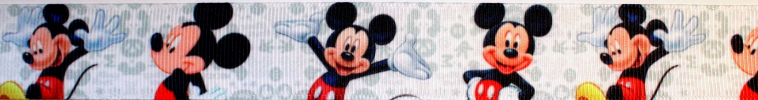

#MM05 (grosgrain, 2,5 cm)
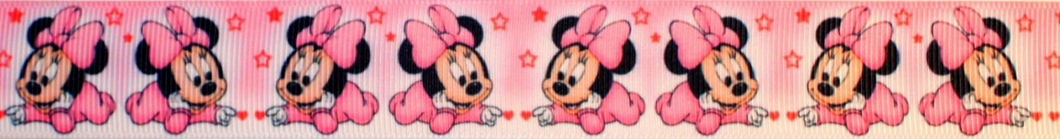

#MN01 (grosgrain, 2,5 cm)

#MN02 (grosgrain, 2,5 cm)

#MP01 (grosgrain, 2,5 cm)
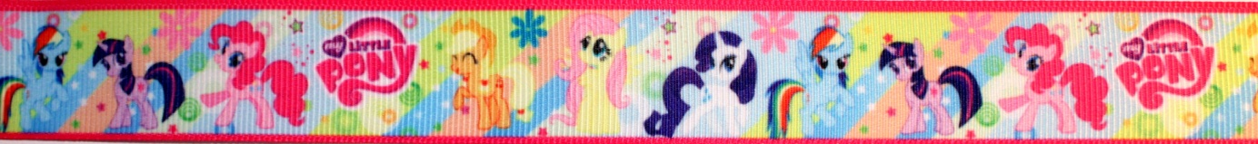

#MP02 (grosgrain, 2,5 cm)
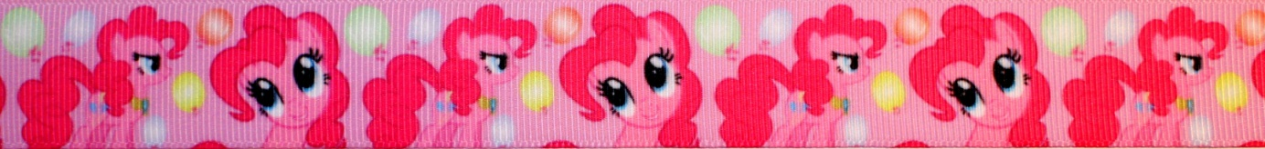

#NK01 (grosgrain, printing by golden colour, 2,5 cm)

#OR01 (woven cotton, 5 cm)
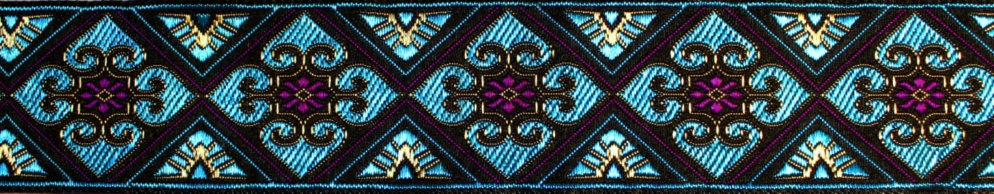

#OR02 (woven cotton, 2,5 cm)

#PA01 (grosgrain, 2,5 cm)
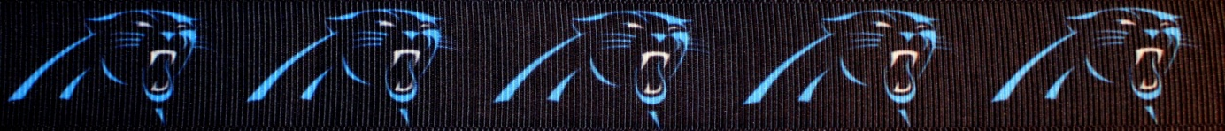

#PC01 (grosgrain, 2,2 cm)

#PL01 (grosgrain, 2,5 cm)
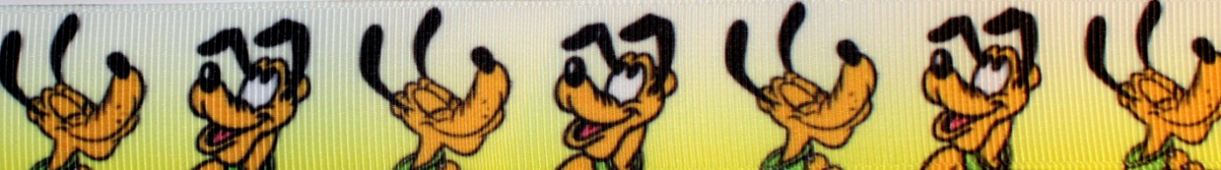

#PM01 (grosgrain, 2,5 cm)
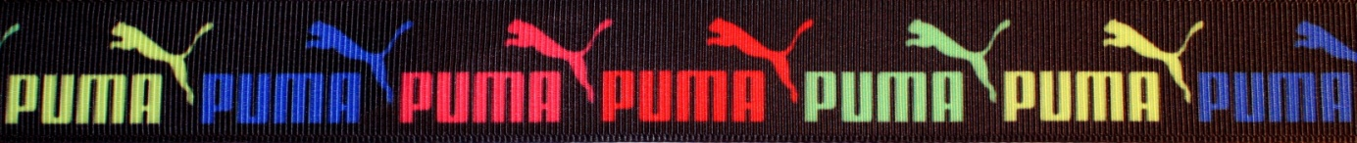

#RD01 (woven cotton, 1,6 cm)
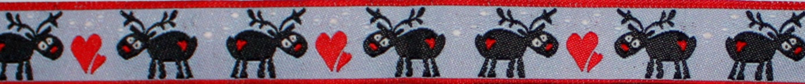

#RD02 (woven cotton, 1,6 cm)

#RH01 (grosgrain, 2,5 cm)
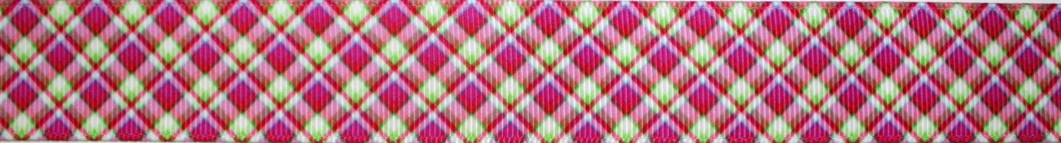
#RH02 (grosgrain, 2,5 cm)
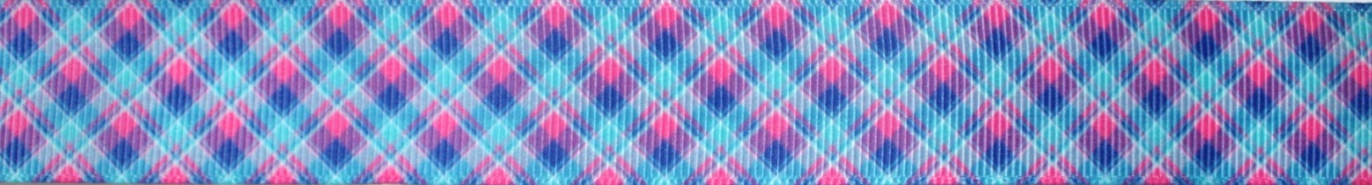

#RH03 (grosgrain, 2,5 cm)
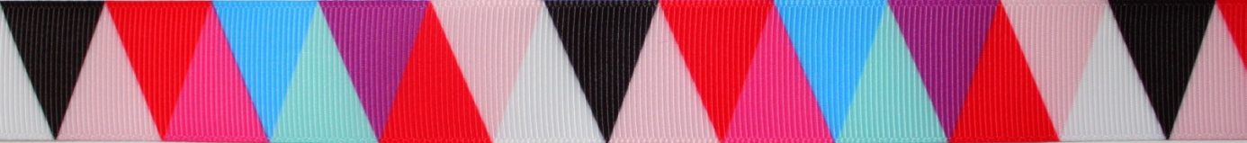

#RH04 (grosgrain, 2,5 cm)

#RH05 (grosgrain, 2,5 cm)

#RH06 (grosgrain, 2,5 cm)
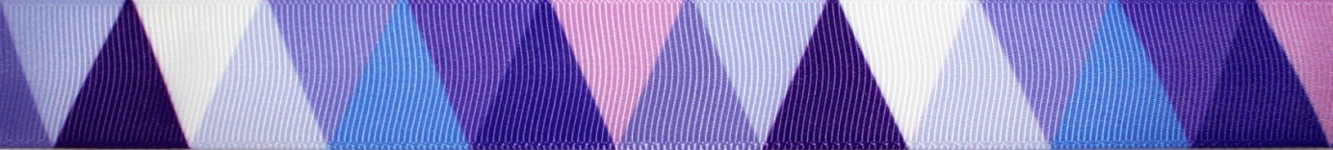

#RO01 (grosgrain, 2,2 cm)
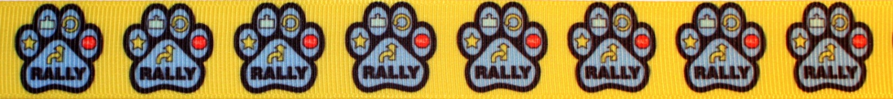

#RX01 (reflex, 2 cm)

#SB01 (grosgrain, 2,2 cm)

#SK01 (woven cotton, 2,2 cm)

#SK02 (woven cotton, 2,2 cm)

#SP01 (grosgrain, 2,2 cm)
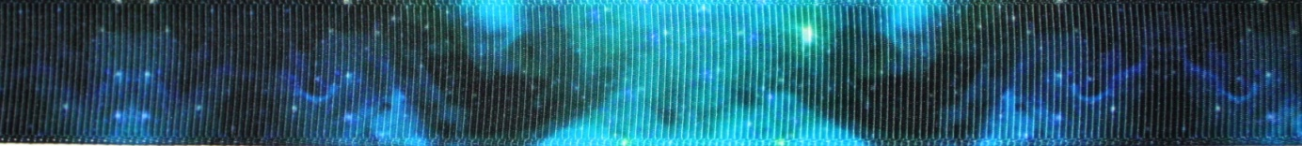

#SP02 (grosgrain, 2,2 cm)
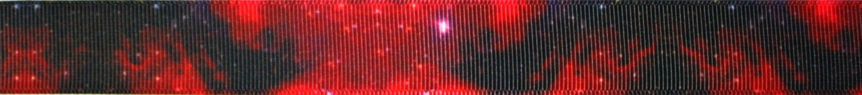

#SP03 (grosgrain, 2,2 cm)

#SU01 (grosgrain, 2,5 cm)
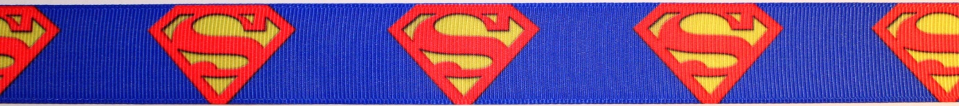

#SU02 (grosgrain, 2,5 cm)
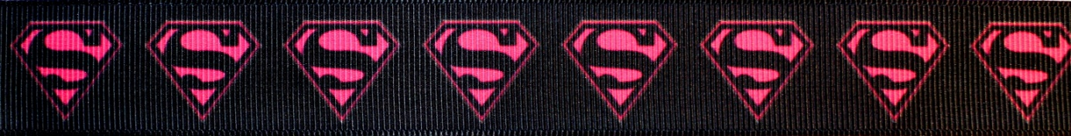

#SU03 (grosgrain, 1 cm)

#TO01 (grosgrain, printing by silver colour, 2,5 cm)
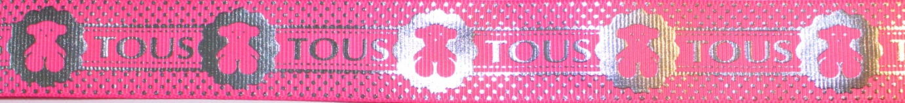

#TO02 (grosgrain, printing by silver colour, 2,5 cm)

#TR01 (grosgrain, 2,5 cm)
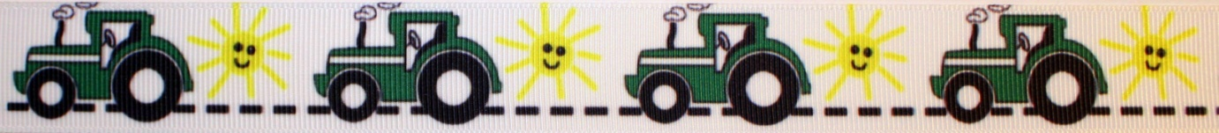

#TS01 (grosgrain, 4 cm)
#UK01 (grosgrain, 2,5 cm)
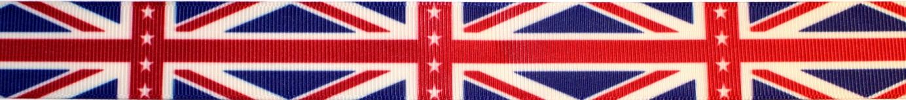

#UK02 (grosgrain, 2,2 cm)

#UK03 (grosgrain, 1,5 cm)

#UN01 (grosgrain, 2,5 cm)

#US01 (grosgrain, 2,5 cm, 4 cm, 5 cm)
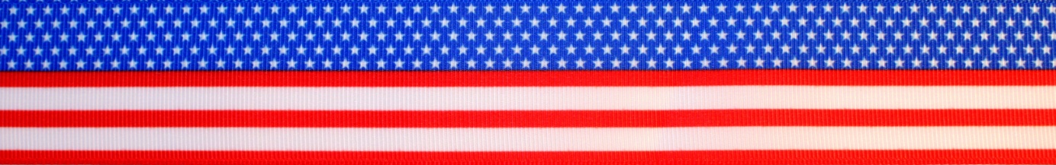

#US02 (polyester, 3,8 cm)
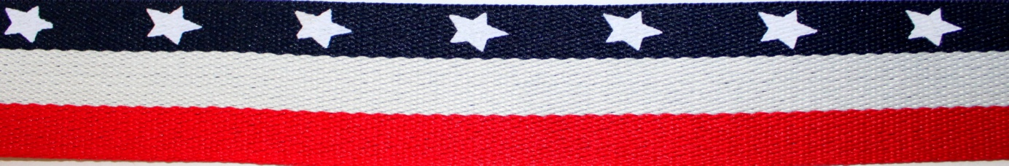

WEBBINGS
- Materials: polypropylen, polyester, cotton
- Monochrome webbings according your choice, any widths
- Various weight/rigidity of webbings

#BU02 (woven polypropylen, 2,5 cm)

#BU03 (woven polypropylen, 2,5 cm)

#CM05 (woven polypropylen, 2,5 cm)
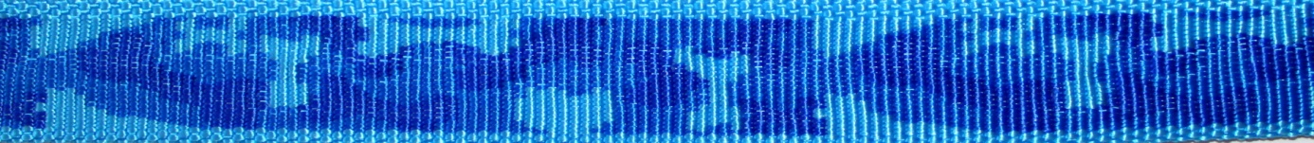

#FR03 (cotton, 4 cm)
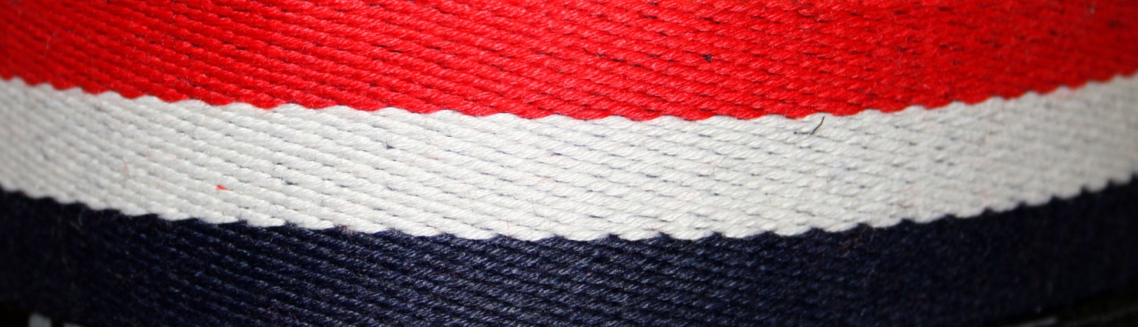

#RW01 (polyester/cotton, 2,3 cm, 3,8 cm)
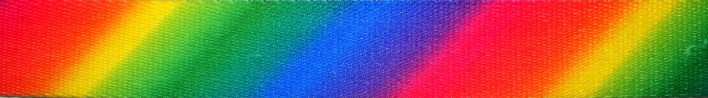

#UT01 (cotton, 3,8 cm)
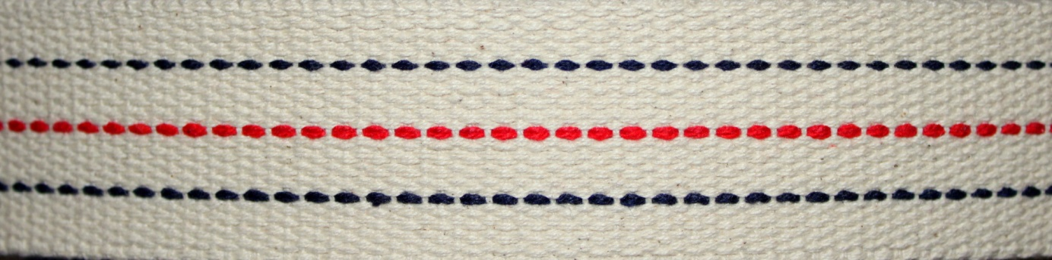

FOSA-DOG
27.10.2020

